Past Masters of the Lodge
Fritz Mc Lean | PDDGM PJGD | 1985
Doodnauth Persaud | PDGM PJGD, | 1986
Chandranauth Persaud |  | 1987
David Griffith | PDistSGW | 1989
Carl Rodrigues | PDistSGW, | 1990
John Peroune | PAGDC, PDistGDC | 1991
Donald Saywack | PAGDC, PDistGTres | 1992
Seu Sarran Prasad | PDistGStwd | 1995
Godfrey Proctor |  | 1996
Deo Sahai Naraine |  | 1997
Dr. Harold Davis | PDistSGW, | 1998
Amarnath Muneshwer | PDistSGW | 1999
Dr. Martin Boodhoo | PDistGSwdB | 2000
Jan Bahadur Singh |  | 2001
John Lewis | PDGStdB | 2003
John Lewis | PDGStdB | 2004
John Peroune | PAGDC, PDistGDC | 2005
John Peroune | PAGDC, PDistGDC | 2006
Dr. Harold Davis | PDistSGW, | 2007
Henry Rebeiro | PAGDC | 2008
Henry Rebeiro | PAGDC | 2009
Alister Meredith |  | 2010
James Mentore | DGStdB | 2011
James Mentore | DGStd | 2012
Tristan Gomes | PDGSupWks | 2013
Timothy Jonas |  | 2014
Tristan Gomes | PDGSupWks | 2015
James Mentore | PDGstdB | 2016
Andre Cummings |  | 2017
Andre Cummings |  | 2018
Tristan Gomes | PDGSupWks | 2019

Klubba Lodge No 9103 EC
No.12 in the District of Guyana

RW BRO ROYSDALE ALTON FORDE
DISTRICT GRAND MASTER

Warranted 1983 & Consecrated 9th June 1984

W. Bro. Tristan Wendell Gomes
Worshipful Master
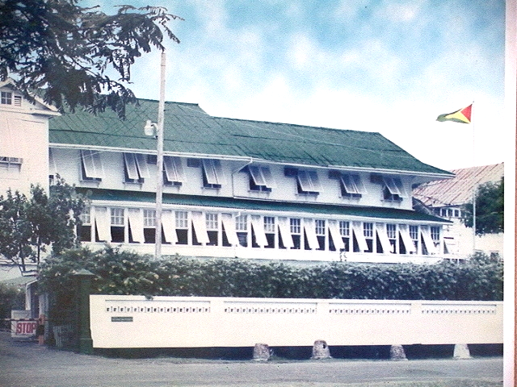

The Georgetown Club
Date 18th May 2019
Dear Sir and Brother,

You are requested to attend the Installation Meeting of the Lodge to be held on Tuesday, 4th June 2018 at 18.00 hrs.

By Command of the worshipful master
Yours fraternally
J. E. Mentore
Secretary.

188 Lamaha Gardens,
Georgetown
Guyana 226 4286

AGENDA.

- To open the Lodge.

- To read and confirm the minutes of the Regular Meeting of the Lodge held on Monday 1st April, 2019

- To Receive the District Grandmaster and Delegation from District Grand Lodge.

- To Install the WM and Invest Officers of the Lodge for the year 2019-2020

- Risings

- Bag of Benevolence

- To Close the Lodge

Afterproceedings will take the form of a Dinner, the cost of which will be approximately G$3,000.00 per plate. You are asked to inform the Secretary by latest Tuesday 30th May if you will be dining, the number of guests you will inviting, and pay in advance.

Dues $8000.00 now payable to the Treasurer

“…no brother shall be admitted into any meeting of the Grand Lodge, or any subordinate Lodge without the clothing appropriate to his rank under Grand Lodge.”
(Reg. No.239)

OFFICERS FOR 2018/2019.

W. Bro Tristan W. Gomes PDGSupWks | WM
W. Bro Andre C. Cummings | IPM
W. Bro Nicholas Chuck A Sang | Senior Warden
Bro John Chin | Junior Warden
W. Bro Henry G. Rebeiro PAGDC | Chaplain
W. Bro John Lewis PDGStdB | Treasurer
W. Bro James Mentore DGStd | Secretary
W. Bro John A. Peroune PDDGM | Dir of Ceremonies
W. Bro Fritz C. Mc Lean PDDGM, PSGD | Almoner
W. Bro Amarnauth Muneshwer PAGDC | Charity Steward
Bro Roger Peroune | Senior Deacon
Bro Devin Munroe | Junior Deacon
W. Bro Paul Ronald Reece PDGStdB | Asst Dir of Ceremonies
W. Bro David M. Griffith PDistGSW | Assistant Secretary
Bro Deoanand Dass | Inner Guard
Rt. W. Bro Doodnauth Persaud PDGM | Steward
W. Bro Lalbahadur Singh PJGD | Steward
W. Bro Dr. Harold B. Davis PDGSW | Steward
Bro Kevin Fogenay | Steward
Bro Fibyan Denny | Steward
W. Bro Timothy Jonas | Tyler

Lodge Committee

Worshipful Master, IPM, Wardens, Treasurer, Secretary, Director of ceremonies, W Bros Doodnauth Persaud & Fritz Mclean. ( Four constitute a quorum.)

Audit Committee

Senior and Junior Wardens

The regular Meetings of the Lodge are held at the Georgetown Club, 208-209 Camp Street,
North Cummingsburg, Georgetown on the First Tuesday of February, March, June,
September and December, and the First Monday of April, October and November.
Elections are held in April and the installation and investiture of officers are held in June.
The Lodge Committee meets at 17:00hrs at the Georgetown Club on the Tuesday following the meeting.

