#### ANTIENT CHARGE:-

***"From antient times no Master or Fellow could be absent from his Lodge especially when warned to appear at it without incurring a severe censure, unless it appeared to the Master and Wardens that pure necessity hindered him."***

##### AGENDA

1. To Open the Lodge.

2. To Confirm the Minutes of the Regular Meeting for the month of

***October 2018.***

3. To Receive the Treasurer’s Report for the months of ***September and October 2018.***

4. Masonic Information

5. To Ballot for and if successful, to initiate into the Mysteries and Privileges of Freemasonry

(1).Mr. Deodat Indar D.O.B 2nd May 1980

Address: Lot 223 Tuschen E.B.Essequibo

Occupation: Finance Controller/ Company Secretary- Sterling Products Limited

(2). Mr. Lancelot G. Wills D.O.B 12th December 1966

Address: Lot 15 Railway Line Montrose, ECD

Occupation: Deputy Commissioner General- Guyana Revenue Authority

Proposed by: W. Bro R.A. Forde Seconded by: W. Bro R.A. Cameron

6. Risings.

7. B.O.B.

8. To Close the Lodge.

The W.M will be assisted by the following Brethren: Bro. K.Griffith- N.E Corner, WBro. DA King- Secrets, Bro.Dr.RE Brathwaite-Working Tools,WBro.RA Cameron- Tracing Board, Bro.Dr. CFF Mc Ewan -Charge after Initiation

Rehearsals 10-28-18, 11:00 hrs., 10-31-18, 18:00 hrs.

*Members are reminded that their Lodge Dues of $12,000 are due, as well as their* ***contribution of $18,000 to the Steward’s Fund.***

**Dress: - Black or Dark Suit, White Shirt and Black Tie.**

*The only Masonic Jewels permitted are those of the Royal Arch and the Craft*

**MOUNT OLIVE LODGE No 385 E. C.**

**2017-2018**

|  |  |
| --- | --- |
| W.Bro. A. V. Kellman | Worshipful Master |
| W.Bro. R. A. Cameron | Imm. Past Master |
| **OFFICERS** | |
| Bro. Dr. C.F. McEwan | Senior Warden |
| Bro. K.A. Griffith | Junior Warden |
| W.Bro. R.A. Forde, R.W DGM | Chaplain |
| W. Bro. T.A. Meredith, *DistAsstGSE (RA*)  W.Bro. J. A. Lewis, *PDist* JGD | Treasurer  Secretary |
| W.Bro. A.A.G. Joseph | Dir. of Ceremonies |
| W.Bro. J. Lewis, *PDistGStdBr; DistGAlmoner (RA).* | Charity Steward |
| W.Bro. H. G. Rohlehr, *PDistSGW* | Mentor |
| Bro. R.A. Doobay | Senior Deacon |
| Bro. R.O. Fanfair | Junior Deacon |
| Bro. K. A. Pindar | Asst. Dir. of Cere. |
| W. Bro. D. A. King *DistGStwd (RA)* | Asst. Secretary |
| Bro. Capt. K.R.G. Moore | Inner Guard |
| W.Bro. C.McG. Kirton, PDSGW, &CGP(RA)  W.Bro. K. I. Philadelphia, *Dist.SGW; PDistGStdB(RA)*  W.Bro. G.I McDavid, *PDist.JGW, Dist.G.SwdBr(RA)* | Steward  Steward  Steward |
| W. Bro. E. O. S. Hanoman*, DistJGD* | Steward |
| Bro*.* Cdr. O. G. Porter | Steward |
| Bro. I. S Edwards | Steward |
| Bro. G. Vaughn | Steward |
| Bro. Dr. R.E Brathwaite | Steward |
| Bro. J. G Khan | Steward |
| Bro. R. R. Meredith | Steward |
| Bro. Lt. Col. Delbert George | Steward |
| W. Bro. Dr. R.O. Cummings, *Dist.SGW, PDist.GN (RA)*  Bro. L.C. Robinson | Steward  Tyler |
| **LODGE COMMITTEE** | |
| W.Bro. A. V Kellman | Worshipful Master |
| Bro. R.A. Cameron  Bro. Dr. C.F. McEwan | Imm. Past Master  Senior Warden |
| Bro. K.A. Griffith | Junior Warden |
| .Bro. T.A. Meredith, Dist. Asst.GSE(RA) | Treasurer |
| W.Bro. J.A. Lewis, *PDist. JGD* | Secretary |
| Bro. K. A. Pindar | Member |
| Bro. R.A. Doobay | Member |
| Bro. R. O Fanfair | Member |
| **AND ALL PAST MASTERS** | |

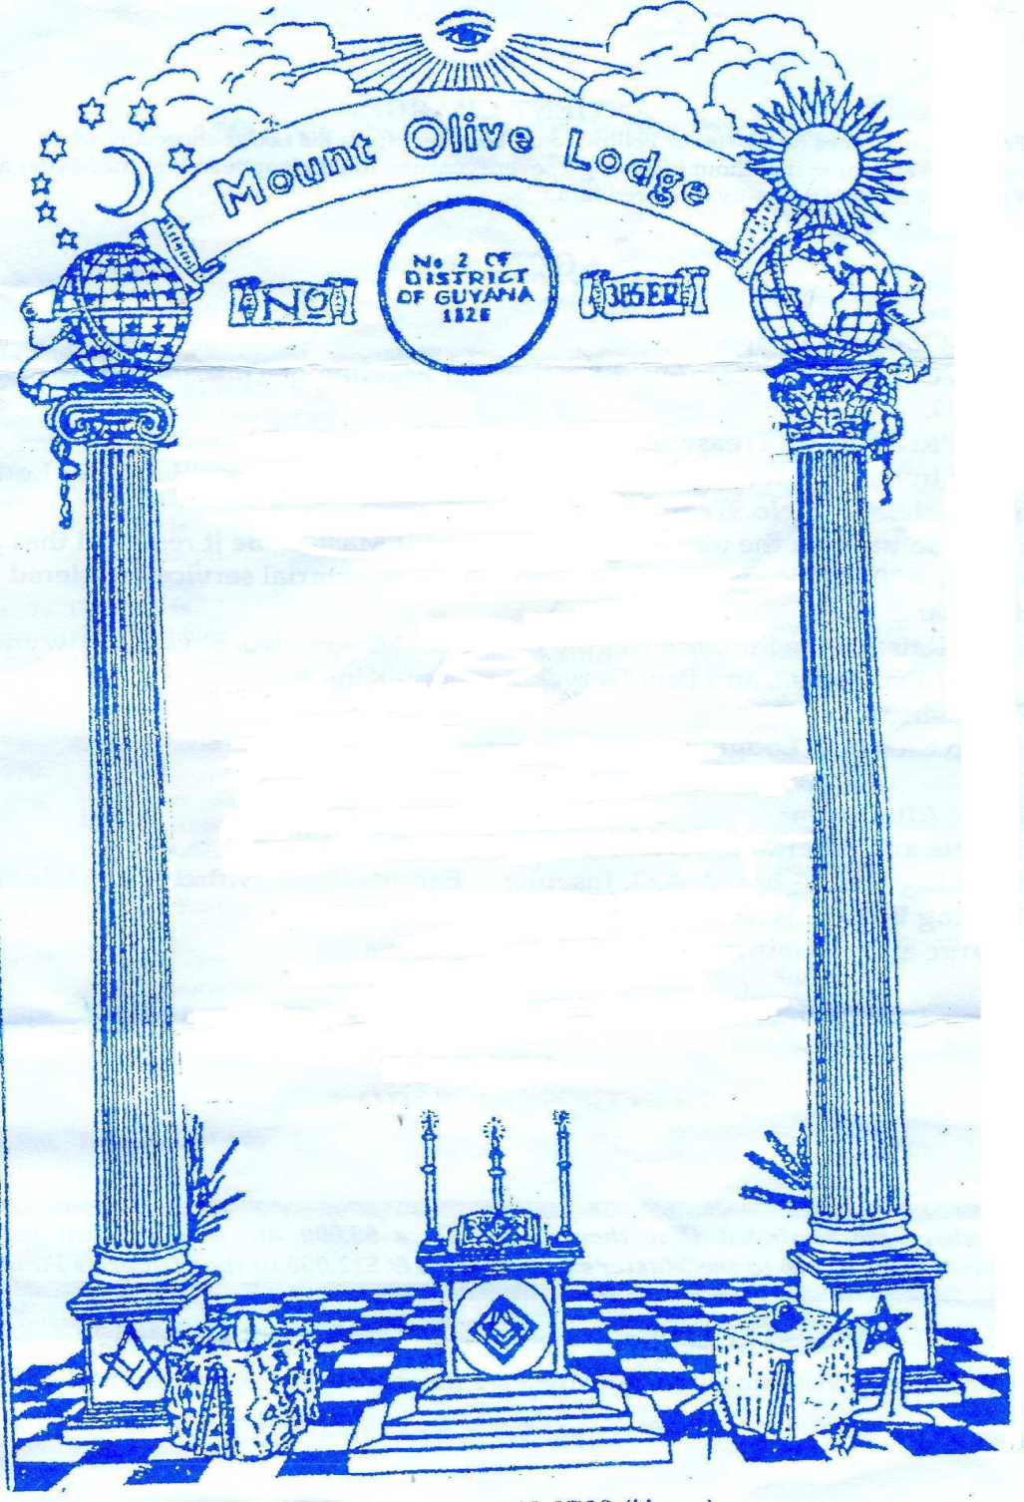

|  |  |
| --- | --- |
| **PAST MASTERS** | **End of Term**  **of Office** |
| Cecil Norman **MURRAY, A.A***PA.G.Reg, PDistGN(RA*) | 1973 |
| Hon. Mr Justice George *Adolphus Grenville* **POMPEY,***PDistSGW, PDistGReg(RA)* | 1977 |
| Dennis Francis **CORLETTE,***AA* | 1980 |
| Noel Leroy **HOLDER,** *DistGDC, PGStdBr(RA), DistDepGDC(RA),* | 1991 |
| Ronald Owen **ROBINSON**, AA | 1992 |
| William Hansel **BARROW,** MS, *PDistJGD, PDistGAlmoner,(RA)* | 1994 |
| Dr Michael Irving Lucius **JOSEPH,** *PDistGSwdBr, PDistGStwd(RA)* | 1996 |
| Sydney McDonald **ROBINSON***, PDistSGW, PDistGN(RA)* | 1997 |
| Clifford Barrington **REIS***CCH, PDistSGW* | 1998 |
| Herman Godfrey **ROHLEHR,** P*Dist.SGW.* | 1999 |
| Gordon Ian **McDAVID, PDistJGW***, Dist1stAsstGSo(RAj* | 2002 |
| Kenrick Ivor **PHILADELPHIA,** *DistGSwdB***,** *PDistGstdBr(RA)* | 2003 |
| Dr. Rudolph Othneil**CUMMINGS,** *Dist.SGW, PDist.GN(RA)* | 2004 |
| John **LEWIS,** *PDistGStdBr. Dist.GStdBr(RA)* | 2005 |
| Collin McGregor **KIRTON,***Pres.Dist.BdGP,PGStdBr(RA), Pres.DistC.GP(RA)* | 2006 |
| John Alexander **LEWIS,** *PDist.JGD* | 2007 |
| John Alexander **LEWIS,** *PDist.JGD* | 2008 |
| Dr.Nicholas Adrian **MCLEAN** | 2009 |
| Kevin Wilwood Katz **SAUL** | 2010 |
| Errol Oswald Seenanan**HANOMAN,** *Dist.GPurs* | 2011 |
| Errol Oswald Seenanan**HANOMAN,***Dist.GPurs* | 2012 |
| Roysdale Alton **FORDE, R.W. DGM** | 2013 |
| Andre’ Anthony Garvin **JOSEPH**  Deryck Anthony **King Dist. G.Stwd (RA)** | 2014  2015 |
| Trevor Arlington **MEREDITH**, *Dist Asst. GSE* | 2016 |
| **Rodwick Akintinde CAMERON** | 2017 |

Centennial Warrant 1953

**W. Bro. ANDRE VAUGH KELLMAN**

**WORSHIPFUL MASTER**

**Masonic Hall**

86 Carmichael Street,

Georgetown, Guyana.

Dear Sir and Brother,

You are hereby requested to attend a

Regular Meeting of the Lodge **on Thursday**

November 1st **2018** at **18:30 hrs.** for the

purpose of transacting **General Business.**

By command of the Worshipful Master.

Yours Sincerely and Fraternally,

**J.A. Lewis**

**Secretary**

**Bro. Secretary`s Telephone 622-5848**